UNDERGRADUATE RESEARCH EXPERIENCE
(UREx)
PROJECT REPORT
Development of Autonomous Movement and Navigation of a Sentry Robot for
RMUC (Supercapacitor Buffer Implementation)
Ng Weiliang (A0281846U)
Supervised by:
Dr Lim Li Hong Idris and Mr Chew Wanlong, Nicholas
Engineering Design and Innovation Centre,
College of Design and Engineering
National University of Singapore

Abstract
This project focuses on improving the autonomous navigation capabilities of the
Robomaster Sentry robot for participation in the Robomaster University Championship (RMUC). RMUC challenges university teams to design advanced robots with enhanced power management capabilities to work with the limited power available, by developing a supercapacitor board with bidirectional charging and discharging capabilities to support peak power demands of the sentry robot during intense competition. Key features to maximize the power source available include programmable bidirectional current limiting for effective load sharing between supercapacitors and batteries, as well as simultaneous charging of supercapacitors and powering of the robot under constant power constraints. An efficient Switch Mode Power Supply (SMPS) utilizing a four-switch bidirectional buck-boost topology was developed. The design process encompassed circuit simulation, prototyping, and load testing, ensuring a robust solution tailored to RMUC's unique demands. The simulation results are presented alongside observations of the converter’s performance under step loads. This report documents the technical approaches, findings, and challenges, and proposes future work to refine the system’s performance for RMUC.

Preface and Acknowledgements
This project represents the culmination of technical learning and practical application during my undergraduate journey. I am grateful to the National University of
Singapore (NUS), the Provost's Office, and the Engineering Design and Innovation
Centre (EDIC) for facilitating this research through the Undergraduate Research Experience (UREx) program.
Special thanks to my supervisors, Dr Lim Li Hong Idris and Mr Chew Wanlong,
Nicholas, for their guidance. I also extend my appreciation to the NUS Calibur
Robotics team for their support with the fabrication of the supercapacitor controller board.

Table of Contents
Abstract 1
Preface and Acknowledgements 1
1. Introduction 3
1.1 RMUC Rule Analysis 4
1.2 Project Specification 4
1.3 Overview of Bidirectional Power Conversion Topologies 6
1.3.1 Synchronous Buck Converter (LT8228) 7
1.3.2 4 Quadrant Bipolar Output Synchronous Converter (LT8714) 8
1.3.3 4 Switch Buck-Boost Topology (LT8708) 8
1.3.4 Analog vs MCU controlled switching regulators 9
1.4 Summary 10
2. System Development 12
2.1 Overview 12
2.2 Power Components Calculation 12
2.3 Programmable bidirectional input current limiting 12
2.4 Auxilliary Components Calculation 13
2.5 LTSpice Simulation 14
2.6 PCB Design and Layout 15
2.7 Mounting of Components 16
3. Results and analysis 16
3.1 Challenges and Limitations 18
4. Conclusion 24
5. Future Work 25
Citation and References 26
Appendix 28
A. Video Demonstration 28
B. LTSpice Simulation Schematic 28
C. PCB layout 28
D. Overall Modified Hardware Diagram for Sentry 28

1. Introduction
Robomaster, created by DJI, is a premier robotics competition that brings together university teams from around the world to design, build, and compete with robots in strategic, fast-paced battles. The competition is divided into two tiers: the
Robomaster University League (RMUL), aimed at newer teams, and the Robomaster University Championship (RMUC), a larger stage featuring increasingly complex physical obstacles, including ramps and uneven terrains, tougher opponents, and stricter technical requirements. RMUC pushes teams to innovate and optimise their robots to handle dynamic, real-world scenarios such as navigating steep ramps and uneven terrains.
This year, NUS Calibur Robotics will be competing in RMUC for the first time after participating in RMUL in previous seasons. The transition to RMUC demands significant upgrades to the robots to meet the heightened competition standards. One robot that holds significant potential in this effort is the Sentry, a fully autonomous unit equipped with navigation and aimbot systems. In RMUL, however, the Sentry faced significant challenges. It was built using both LiDAR and visual SLAM (Simultaneous Localization and Mapping), which was computationally expensive and caused performance bottlenecks. As a result, the Sentry often struggled during matches, and the root causes of these issues remained unresolved due to limited testing time.
During this project, the Sentry was initially considered a strong asset for RMUC because of its invincibility rule from the previous season, which made it immune to damage during specific periods of the game. This feature positioned the Sentry as a potentially critical element in the team's strategy. However, with the release of new rules for the current RMUC season, the Sentry's role has been redefined, requiring adjustments to align with the updated competition requirements.
To address the power limitations and improve the performance capabilities of the Sentry robot, this project focuses on replacing the conventional power supply system with a high-efficiency bidirectional supercapacitor-based power management solution. Designed for the demanding conditions of the Robomaster University Championship (RMUC), the system features a 4-switch bidirectional buck-boost SMPS topology, enabling dynamic power flow between supercapacitors and batteries to handle wide variations in input/output voltage and meet peak power demands. By intelligently managing power distribution—charging supercapacitors during idle times and discharging during peak loads—the system ensures compliance with RMUC's strict power limits while maximizing responsiveness. This upgrade significantly boosts the robot's performance during fast movements and intense combat scenarios, optimizing both speed and agility.

The report details the development process, including circuit simulation, prototyping, testing, and verification under real-world stress conditions. It also discusses challenges faced during implementation and offers recommendations for further optimization through digital control to ensure the Sentry robot remains competitive and adaptive to evolving RMUC requirements.

1.1 RMUC Rule Analysis
Firstly, we begin by analysing the rulebook of the RMUC which defines chassis power draw limits, over-power penalties and transient buffer allowances relevant to the design of the proposed supercapacitor buffer.
In RMUC, energy limits for robots such as the Hero, Infantry, and Sentry are tightly regulated. These three robots are the only ones permitted to use a Supercapacitor Module, which has a nominal energy limit of 2000 joules and a maximum measured energy limit of 2200 joules. The Hero robot's chassis power limits ranges from 55 W to 120 W, while the Infantry power limits ranges from 45 W to 100 W, depending on configuration and level. The Sentry robot operates autonomously with a fixed default chassis power limit of 100 W.
Additionally, these robots have a chassis energy limit of 20,000 joules. Once this threshold is reached or exceeded, the robot enters a “weakened” state, where its chassis power limit is automatically reduced to one-third of its standard value.
To manage short-term power surges, robots also rely on buffer energy. The default buffer energy capacity is 60 joules, but this can be temporarily increased to 250 joules by acquiring the Terrain Crossing Buff from the Launch Ramp. If buffer energy is depleted while the robot is still drawing power above the allowed limit, the chassis motors will automatically shut off for five seconds to prevent further violations.
Finally, the power ratings for the peripheral components are as follows: the maximum total capacitance outside of the Supercapacitor Module is limited to 10 mF. For connectors, the peak current rating is 30 A, while the continuous current rating is capped at 15 A.
With the power constraints imposed by competition rules, the supercapacitor buffer becomes essential for delivering a 10x energy boost compared to the standard 60–250 J buffer allowance. This is particularly critical during short but intense bursts of activity such as sudden acceleration, rapid directional changes, or high-speed manoeuvres, where the instantaneous power demand exceeds the steady-state chassis power limit.

1.2 Project Specifications
The purpose of the supercapacitor buffer is to keep the apparent power draw from the battery below the set limits as much as possible, regardless of the actual power drawn by the chassis motors (subject to supercapacitor charge level). Hence, an ideal power buffer will try to charge as much as possible while discharging as little as possible.
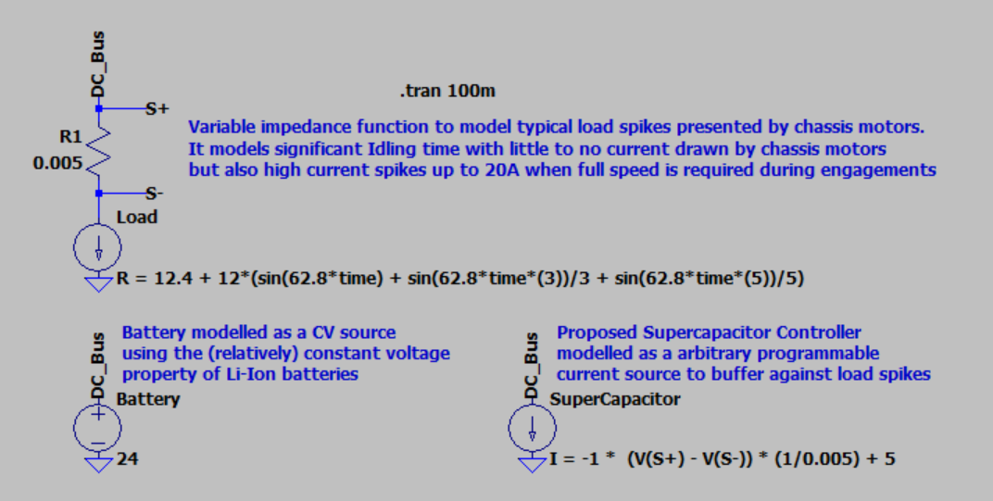
Figure 1: High-Level overview of the power buffer with other subsystems
Firstly, we begin by modelling the load’s time‐varying behaviour and the battery’s nominal characteristics in a circuit simulator. In this example, the load is represented as a variable resistor whose impedance follows an approximated step load, thereby emulating periods of near‐idle current draw interspersed with high‐current “spikes” (up to 20 A) when the motors engage. The battery is approximated by a constant‐voltage (CV) source at 24 V, reflecting the relatively stable terminal voltage of a Li‐ion pack under moderate load.
Next, we introduce the buffer via an “ideal” programmable bidirectional current source. This current source is designed to source or sink current in such a way that the net battery current remains below the ruled power limit, even if the load demand increases briefly beyond limits. Conceptually, whenever the chassis motors demand more current than the battery is allowed to supply, the buffer discharges just enough to meet that excess demand in conjunction with the power that we can draw from the referee system port. Conversely, when load demand falls below the battery’s set current limit as the robot idles/prowls, any available headroom is used to charge the buffer in preparation for the next engagement. The current of the buffer is hence defined as follows:
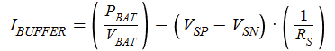
in other words, the buffer current is set to be the “allowed” current from the battery minus the load current sensed using a high-side current shunt. The buffer supplies (or absorbs) whatever current is needed so that the battery current stays at or below its prescribed limit. If the load demands more current than that set limit, the buffer discharges (i.e., supplies the difference); if the load demands less, the buffer is charged by the “excess” current available from the battery. This arrangement allows the battery sees a relatively steady current draw, while the buffer handles temporary transients.
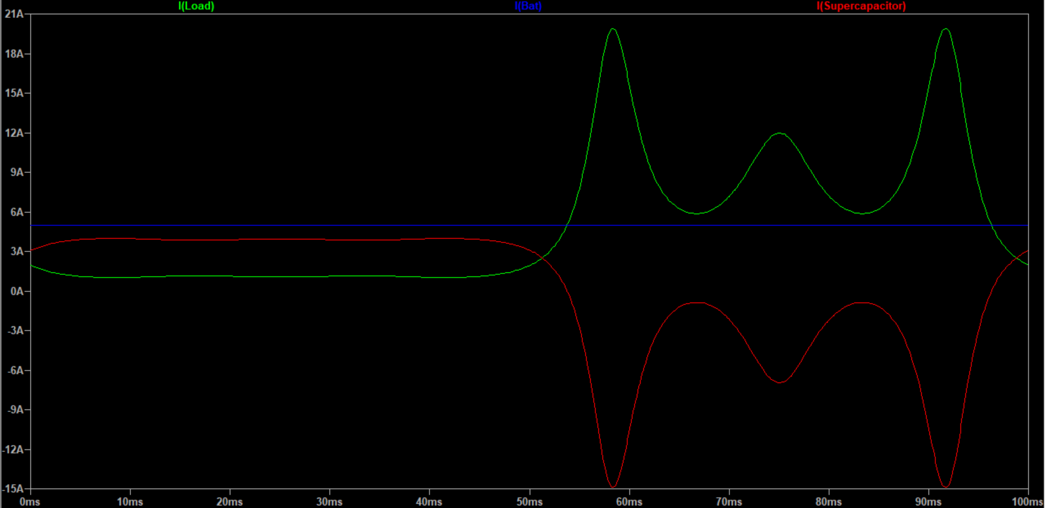
Figure 2: Load sharing between ideal buffer (red) and battery (blue, kept at 5A) during idle and load spikes (green)

In practice, the simple “ideal buffer” equation must be augmented to respect the physical limits of the supercapacitor and connectors. Specifically, the conditions are:
- When the buffer is charging (I_buffer is positive),
- Charge current into the supercapacitor is less than 15A (connector limited)
- Supercapacitor is not fully charged (capacitor voltage is less than V_cap limits)
- When buffer is discharging (I_buffer is negative)
- Discharge current from supercapacitor is less than 15A (connector limited)
- Supercapacitor still has charge (V_cap > 0)
With a supercapacitor energy storage limit of 2000J, the specification of the supercapacitor is chosen as 27V, 5F which conveniently comes off the shelf with energy storage just below specified limits:
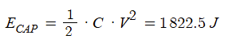
Therefore, the bidirectional DC-DC converter solution must have the following capabilities:
- Arbitrary regulation of input (bus) current from -10 to +10 A
(peak chassis power trade-off to keep power component size small)
- Constant current limit of output (supercapacitor) current within -15A to +15A
(supercapacitor connector MAX current)
3. CV regulation of output to 27V (Supercapacitor MAX voltage)
4. CV regulation of input to 25.2V (Li-ion battery MAX voltage)
(In this paper, we henceforth refer to the power bus port as input, and the supercapacitor port as output)

1.3 Overview of Bidirectional Power Conversion Topologies
LOAM, demonstrating differences in their precision and robustness.

1.3.1 Bidirectional Buck/Boost with Synchronous Half Bridge
The Livox Mid360’s affordability, anti-interference capabilities, and power efficiency
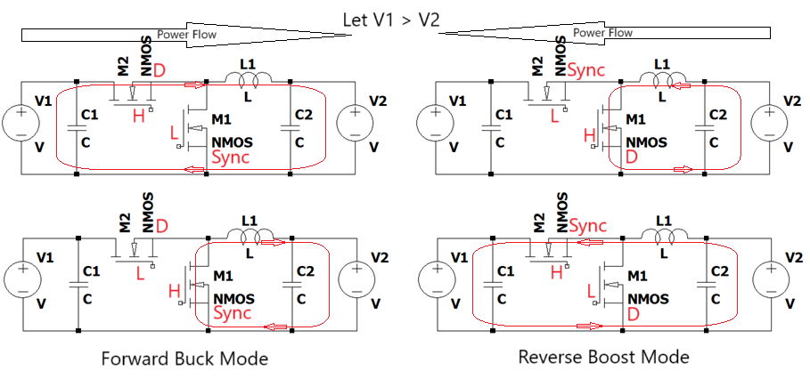
Figure 3: Switching between Forward buck and Reverse boost by changing the role of the mosfet
make it well-suited for competitive settings like RMUC. Figure 4 provides the specifications of the Livox Mid360.
Figure 4: Livox Mid360 sensor specifications

1.5 Simulation Tools for SLAM Testing
Simulation environments, such as Gazebo, have been widely used in robotics research and development. Gazebo provides a realistic platform for testing robot designs, algorithms, and control systems in simulated environments. Its seamless integration with ROS2 makes it an invaluable tool for autonomous navigation and mapping validation. Figure 5 illustrates the interaction between Gazebo, ROS2, and hardware.
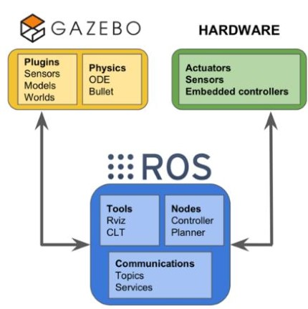
Figure 5: Interaction of Gazebo with ROS2 and hardware.
Tools like Slam Toolbox, which integrate directly with ROS2, provide functionalities such as real-time mapping, localization, and pose graph optimization. Slam Toolbox also enables robots to operate with preloaded maps or dynamically perform real-time mapping (Macenski & Jambrecic, 2021). Yue and He (2023) further emphasise the importance of parameter tuning in SLAM algorithms to ensure stability and accuracy in diverse environments. The ability to adjust parameters such as sensor noise thresholds and pose graph optimization frequency is critical to mitigating performance challenges in dynamic environments.

1.1.5 Navigation Challenges in Competitive Robotics
In competitive robotics settings like Robomaster, navigation systems face unique challenges, including steep gradients, ramps, and tight corridors. The Navigation2 (Nav2) stack, a ROS2-based framework for robot navigation, supports path planning, localization, and obstacle avoidance in both static and dynamic environments.
However, algorithms within Nav2 may struggle with misclassifying certain features. For example, steep inclines can sometimes be interpreted as impassable obstacles, causing navigation failures on upward slopes (Wang et al., 2017).
To address these challenges, robust SLAM systems and tailored navigation strategies—such as waypoint planning or dynamic obstacle handling—must be integrated. Figure 6 provides an overview of the software architecture of the Nav2 stack, highlighting its core components and their interactions.
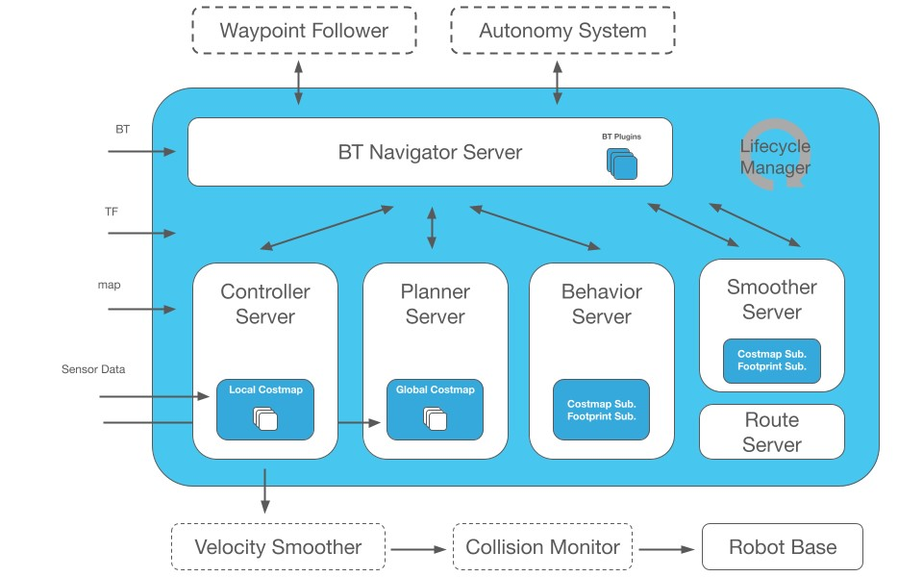
Figure 6: Software architecture of the Navigation2 stack.

1.1.6 Integration of ICP in SLAM Systems
The Iterative Closest Point (ICP) algorithm is a widely used method for refining the alignment of two point clouds. It minimises differences between corresponding points iteratively, achieving highly accurate localization (Besl & McKay, 1992). This technique is vital for tasks requiring high-precision mapping and localization, such as in autonomous navigation. By leveraging Gazebo for controlled testing and employing robust SLAM algorithms, this project aims to optimise the Sentry robot for the challenges of RMUC.

1.1.7 Summary
By transitioning from visual SLAM to LiDAR-based SLAM using frameworks like
FastLIO, this project seeks to address the limitations of traditional SLAM systems. Leveraging simulation tools like Gazebo and integrating advanced algorithms such as Nav2 and ICP further enhance the system’s robustness and adaptability in dynamic and competitive environments. These technologies collectively ensure that the Sentry robot is equipped to handle the unique challenges of RMUC, including steep inclines and tightly packed arenas.

1.2 Objectives
The overarching aim of this project is to enhance the Robomaster Sentry robot by transitioning its perception capabilities from visual SLAM to a more efficient LiDAR-based system. This transformation is essential for addressing the unique challenges of RMUC, including navigation through steep ramps and dynamic environments.
The first goal is to integrate 3D LiDAR for mapping and localization. This involves employing FastLIO to achieve efficient and precise environmental representation.
FastLIO’s real-time mapping capabilities enable the robot to generate accurate 3D maps, a critical requirement for reliable navigation. Localization will also be enhanced through the planned integration of algorithms like Iterative Closest Point (ICP), which will allow for precise alignment of live LiDAR scans with pre-mapped environments.
Another priority is the creation of a robust simulation framework for algorithm testing and validation. Using Gazebo, a simulation environment will be developed to replicate the RMUC competition’s complex terrain, including ramps and tight spaces. This framework will enable controlled testing of SLAM and navigation algorithms, ensuring the robot’s ability to perform in three-dimensional competition settings.
Additionally, the project seeks to establish an efficient workflow for managing pre-calibrated maps. By developing scripts to save and load maps in point cloud data (PCD) format, the robot will be able to operate seamlessly in pre-mapped environments without the need for repeated mapping at each deployment.
Lastly, the project aims to address existing limitations, such as IMU drift, which impacts localization accuracy. Sensor fusion techniques and software optimizations will be explored to mitigate these issues. Moreover, the project will tackle hardware and software constraints, including computational bottlenecks and message processing delays, to ensure smooth real-time operations.
Through these improvements, the Sentry robot will be better equipped to meet RMUC’s rigorous demands, showcasing enhanced adaptability, precision, and reliability in challenging competition environments.

2. System Development
This chapter details the modifications and enhancements implemented to equip the Sentry robot with advanced 3D vision capabilities for RMUC. These include the physical integration of the Livox Mid360 LiDAR, hardware adjustments for power and data handling, and the development of mapping and simulation frameworks.

2.1 Overview
This chapter details the modifications and enhancements implemented to equip the Sentry robot with advanced 3D vision capabilities for RMUC. These include the physical integration of the Livox Mid360 LiDAR, hardware adjustments for power and data handling, and the development of mapping and simulation frameworks.

2.2 Physical Integration
The integration of the Livox Mid360 LiDAR onto the Sentry robot was a critical aspect of this project. This section explores the design and implementation of the physical mount, ensuring compliance with RMUC height restrictions and maximising the sensor’s field of view. The goal was to provide robust structural support while optimising the LiDAR’s ability to detect ramps and other elevated features. As highlighted in the literature review, the Livox Mid360 was selected for its excellent cost-performance balance, making it an ideal choice for integration into the Sentry robot.

2.2.1 Mount Design
The physical mount for the Livox Mid360 was collaboratively designed and fabricated with NUS Calibur Robotics to securely attach the LiDAR to the robot. The mount was made to meet the height constraints of RMUC, 700mm, while ensuring optimal placement for effective environmental sensing. The physical integration of the 3D LiDAR onto the Sentry robot is shown in Figure 7.
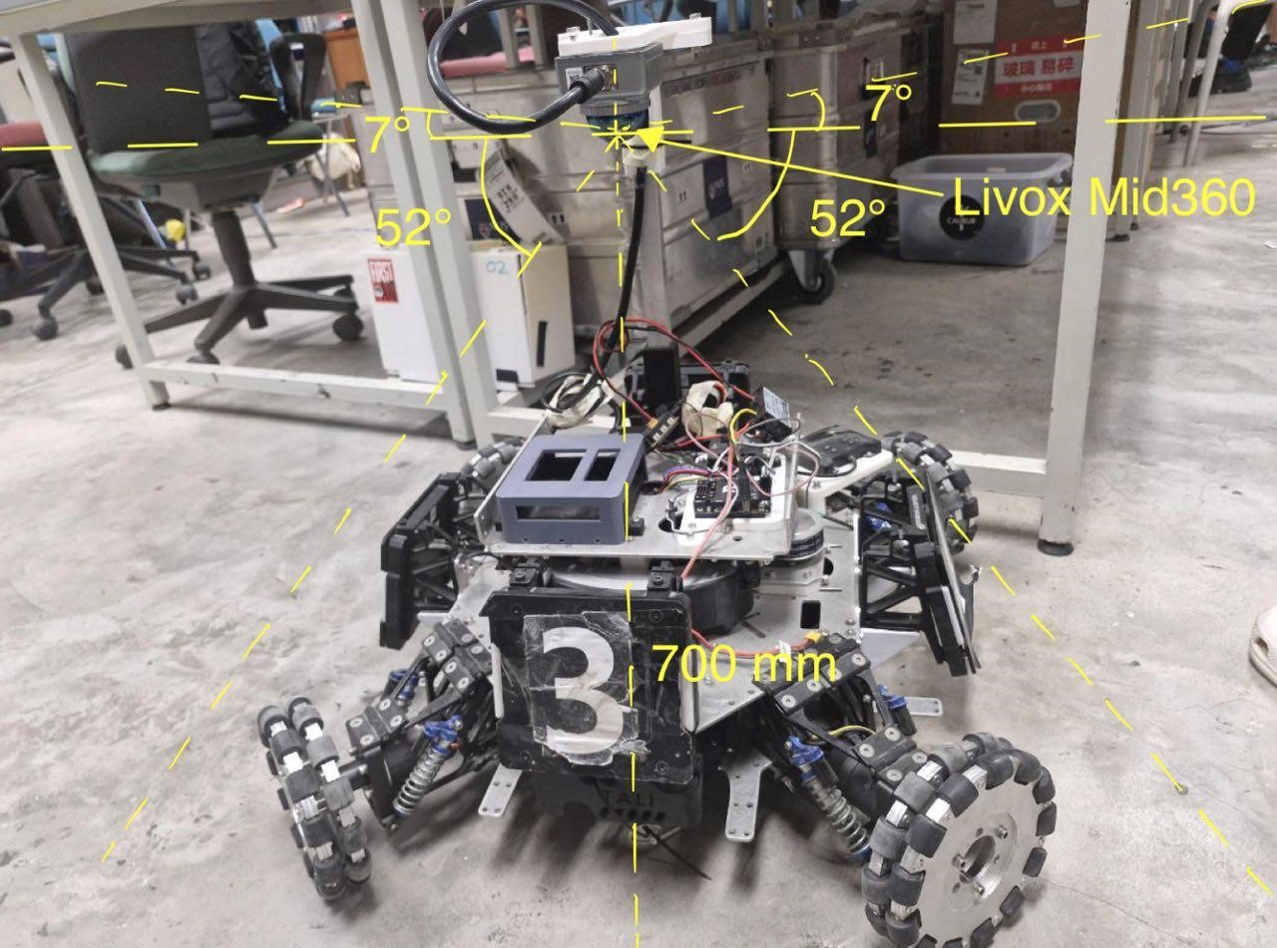
Figure 7: Livox Mid360 Mount Position and FOV
The mount was collaboratively designed and fabricated with NUS Calibur Robotics to securely attach the LiDAR while considering height restrictions, field of view (FOV) optimisation, and competition requirements. The LiDAR was mounted at the maximum allowable height of 700 mm, ensuring compliance with RMUC regulations (DJI, 2024) while optimising environmental sensing.
The downward orientation of the LiDAR leverages its FOV specifications of 360° horizontally and -7° to 52° vertically. This orientation allows the sensor to effectively detect elevated features like ramps and obstacles. The design also accounted for spatial constraints, ensuring no interference with other components while maintaining structural integrity.

2.2.2 Power and Hardware Modifications
To accommodate the Livox Mid360’s power requirements, the Sentry robot’s hardware setup was modified. The Livox Mid360 requires 6.5 W of power with an operating voltage range of 9–27 V DC. Its 100 BASE-TX Ethernet data port enables high-speed communication with the Jetson Orin AGX. A power and data distribution subsystem was implemented to address these requirements, as illustrated in Figure
8.
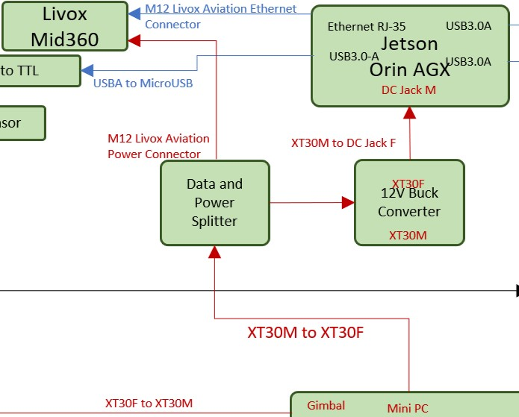
Figure 8: Extracted Hardware Diagram for Livox Mid360
The power output from the Mini PC is routed to a data and power splitter, which separates the power supply and data transmission lines. The M12 Livox Aviation Power Connector delivers power directly to the LiDAR, while the splitter output connects to a 12V buck converter, powering the Jetson Orin AGX. The Jetson Orin AGX is a high-performance computing platform designed for AI applications. With up to 275 TOPS (Tera Operations Per Second) of AI performance, it is capable of handling intensive computational tasks such as real-time SLAM and image processing (NVIDIA, n.d.). For data communication, the Livox Mid360 is linked to the Jetson Orin AGX via an Ethernet RJ-45 port. This configuration ensures reliable power distribution and high-resolution PCD transmission.

2.2.3 Prototype Setup
The prototype setup, as shown in Figure 9, demonstrates the integration of the Livox Mid360 into the Sentry robot’s power and data systems.
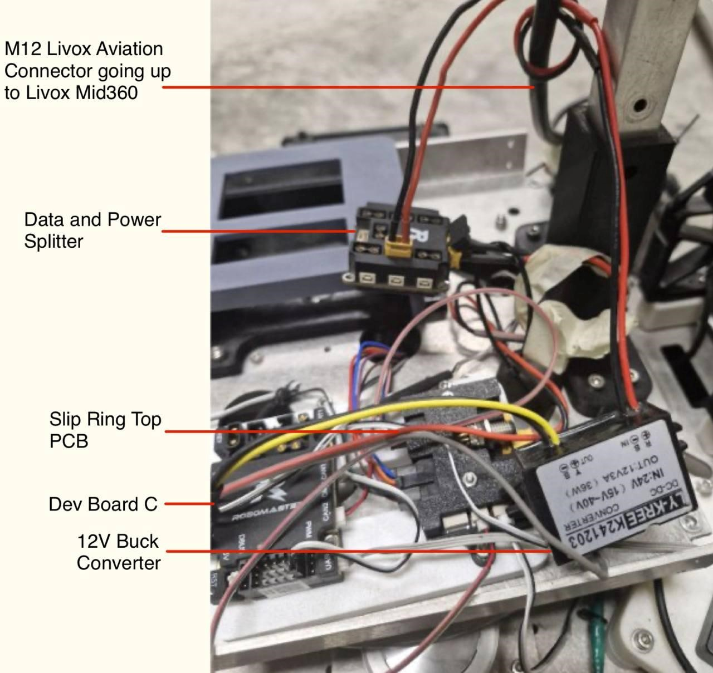
Figure 9: Prototype setup for Livox Mid360 Connections
This prototype setup provides a functional framework for testing and demonstrates its successful deployment on the Sentry robot, where it powered both the Jetson Orin AGX and the Livox Mid360. Further refinements are needed to optimise component placement, creating sufficient space for other critical systems such as the gimbal and launcher.
Additionally, NoMachine, a remote desktop tool, was configured to enable remote access to the Jetson AGX Orin upon startup, streamlining operations by eliminating the need for physical interaction.

2.3 FastLIO Mapping
FastLIO was chosen for its ability to deliver consistent performance in high-speed scenarios like RMUC. It was used for real-time 3D mapping, generating accurate environmental representations. Figure 10 shows the software architecture diagram of FastLIO.
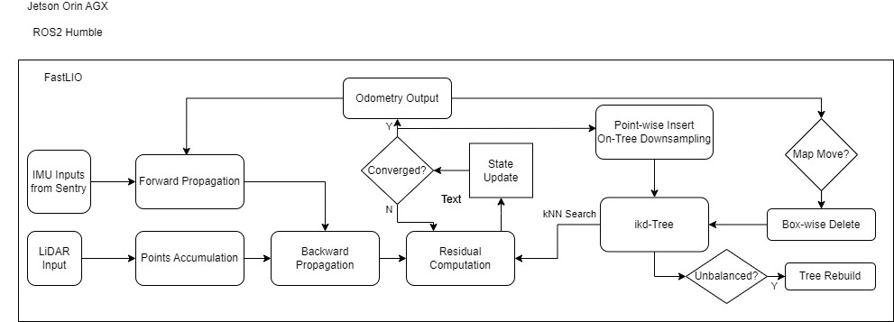
Figure 10: Software Architecture of FastLIO
Some of the required libraries and steps to install will be placed in the appendix.

2.4 Gazebo Simulation
The Gazebo simulation framework was developed to validate mapping, localisation, and navigation algorithms. The custom 3D map, featuring ramps and other competition-relevant elements, enabled controlled testing of system performance. Integrated with ROS2, the framework allowed for seamless testing of Nav2’s path-planning and obstacle-avoidance capabilities. Recognising the need for operational efficiency, scripts were developed to save and load pre-calibrated maps in PCD format, eliminating the need for remapping during each startup. Challenges such as IMU drift and computational bottlenecks were analysed, with potential solutions including sensor fusion and node optimisation.

3. Results and analysis
This chapter presents the results and analysis of the project, focusing on the integration and performance of FastLIO for mapping, the challenges encountered, and the insights gained from simulation testing. The discussion is divided into physical results, where FastLIO was tested with the Livox Mid360 LiDAR, and simulation results, where the Gazebo environment was used to evaluate mapping, localisation, and navigation capabilities. These findings highlight the system's strengths in generating accurate maps while addressing critical limitations, such as IMU drift and computational bottlenecks.

3.1 Physical results
This section presents the outcomes of integrating FastLIO with the Livox Mid360 LiDAR in a hardware environment. The focus is on the system's real-time mapping capabilities and the challenges encountered during testing.

3.1.1 Mapping with FastLIO
The hardware implementation successfully integrated the Livox Mid360 LiDAR with
FastLIO for real-time 3D mapping. The LiDAR's frame rate of 10 Hz and point rate of
200,000 points per second ensured comprehensive environmental scanning. Figure 11 illustrates the point clouds produced during testing.
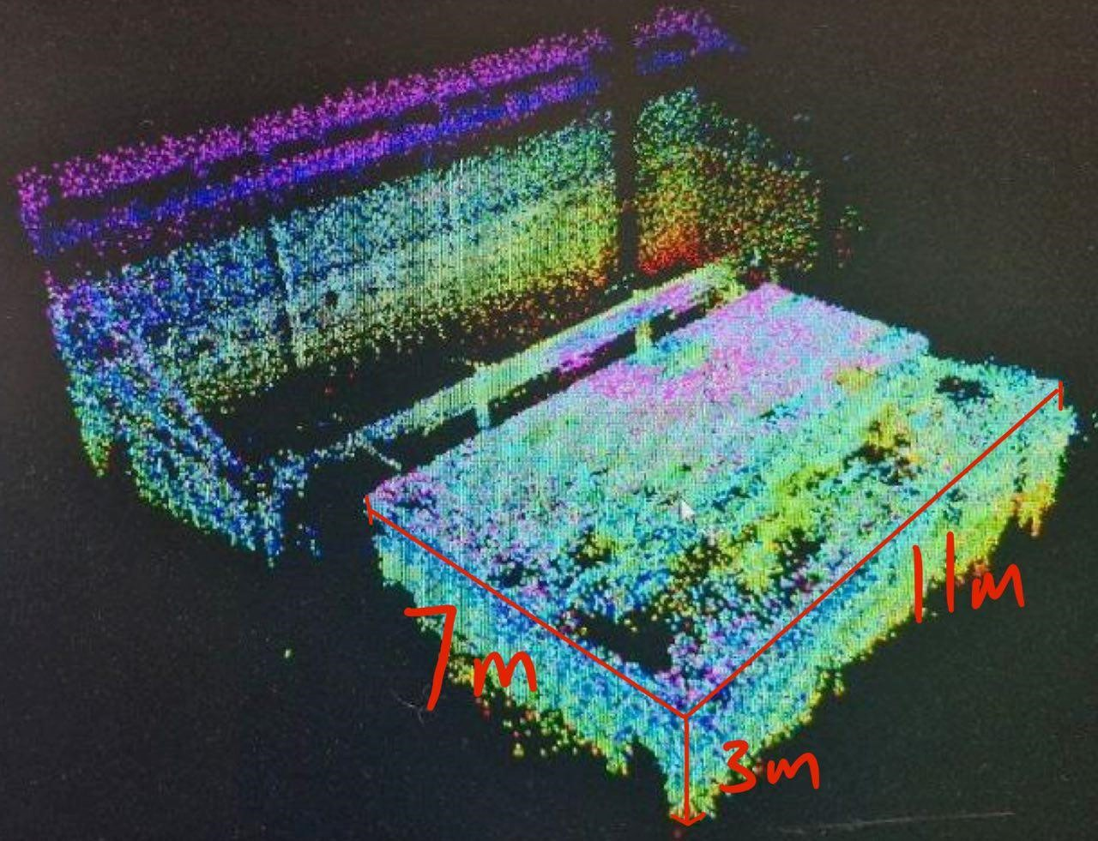
Figure 11: Point Clouds generated with FastLIO and Livox Mid360
To minimise missed points during mapping, the point cloud publishing frequency was increased to 20 Hz. While FastLIO supports odometry frequencies of up to 100 Hz, the system’s performance remains constrained by the LiDAR’s refresh rate and the overall update rate of the hardware. Assessing the accuracy of the SLAM-generated maps would require comparison with other PCD scans obtained from higher-precision 3D LiDAR systems.
To further evaluate responsiveness, the LiDAR was moved in a controlled 2-metre area to observe its ability to reflect real-time orientation changes, shown in Figure 12.
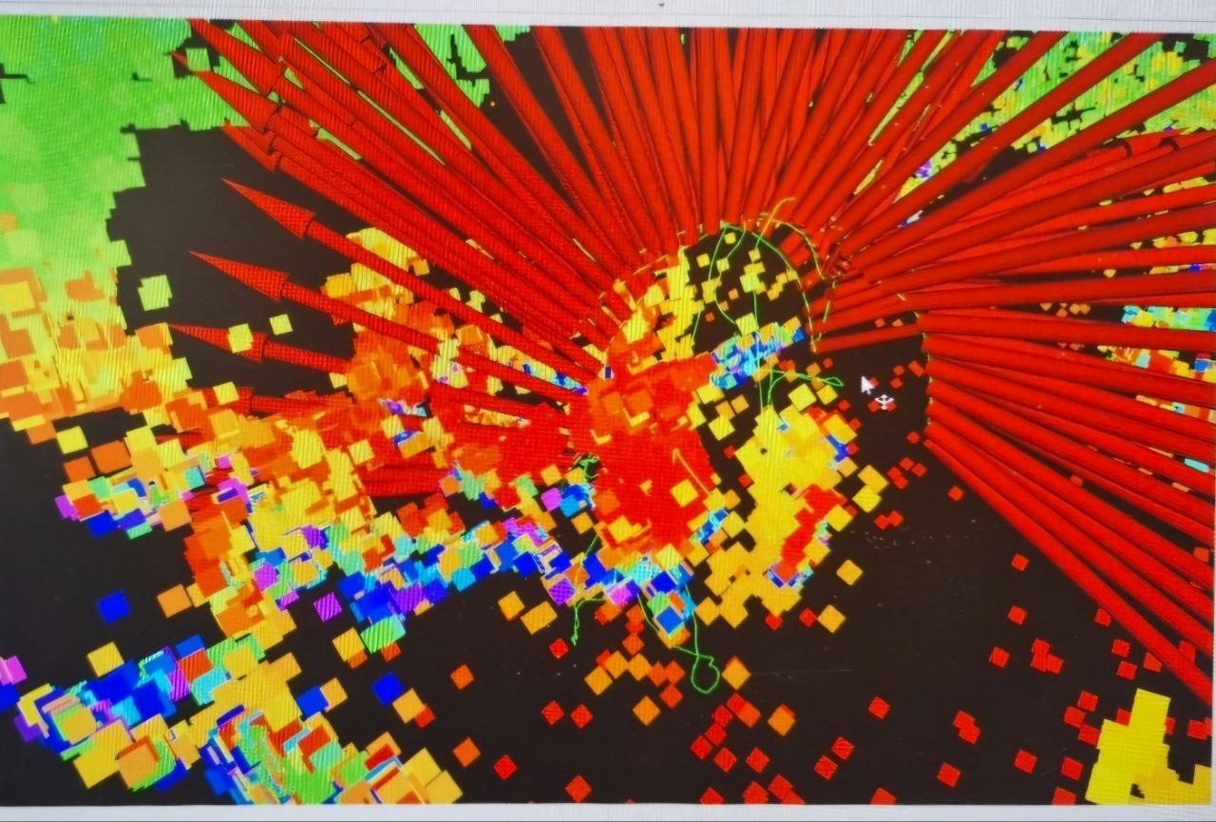
Figure 12: Moving Livox Mid360 around while mapping with FastLIO
The red arrow shows where the LiDAR is currently facing while the green line shows the path that the LiDAR has moved in. This demonstrates FastLIO’s capability to handle fine positional adjustments effectively.

3.1.2 Challenges and Limitations
One challenge identified during hardware testing was IMU drift. The Livox Mid360’s built-in 6-axis IMU exhibited drift when the robot was stationary, as seen in Figure 13. This drift negatively impacted localisation accuracy, particularly in areas with limited unique point features.
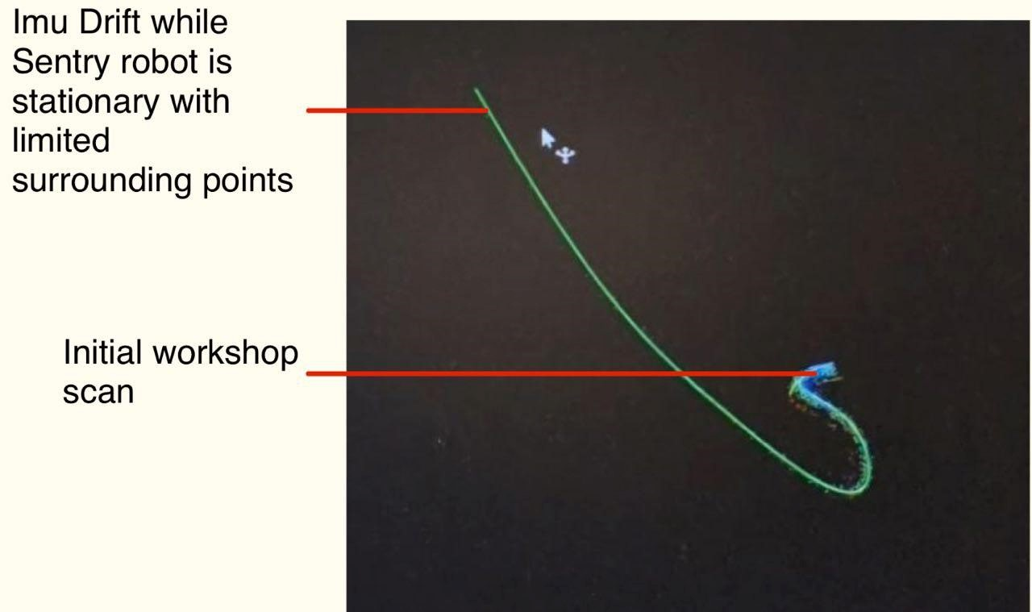
Figure 13: IMU Drift with Stationary Sentry Robot with Limited Points Available To address this issue, future work could integrate the Sentry robot’s external 9-axis IMU. By combining the external IMU with the LiDAR data, the system could achieve more stable localisation, reducing reliance on the less precise internal IMU of the Livox Mid360.
While FastLIO successfully managed real-time mapping, ICP for localization could not be integrated, leaving localization in the hardware environment incomplete. Additionally, the Sentry robot was unable to subscribe to the cmd_vel topic, preventing it from executing movements. These limitations hindered further hardware testing, as navigation could not be validated.
Despite these challenges, the system's ability to generate accurate maps represents a significant milestone. However, the lack of integrated localization and navigation remains a critical limitation, providing a clear area for future development.

3.2 Simulation Results
This section highlights the results from testing the system in a simulated environment developed in Gazebo. It covers mapping, localisation, and navigation performance to test elevation scenarios in RMUC.

3.2.1 Mapping and Movement
According to the RMUC 2024 Rules Manual, typical ramp inclines range between
10° and 15°, such as those in the R2 Ring-Shaped Elevated Ground as shown in Figure 14.
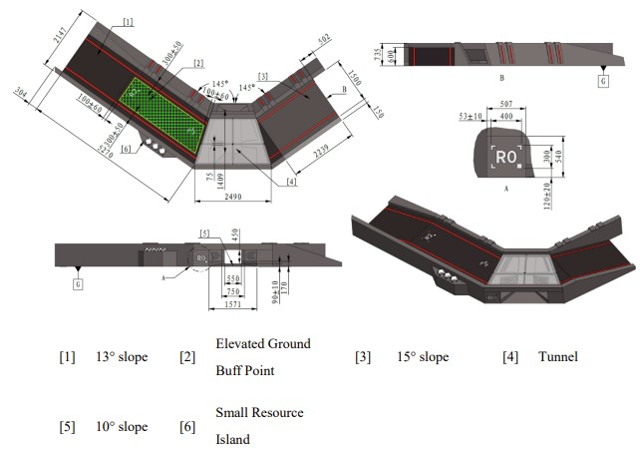
Figure 14: R2 Ring-Shaped Elevated Ground (DJI, 2024)
However, critical areas like the R3 Trapezoid-Shape Elevated Ground feature steeper inclines of 20° and 30°. This elevated ground serves as both a buff point and a strategic sniper position for the opponent’s Hero Robot, making it a highly contested area, as shown in Figure 15.
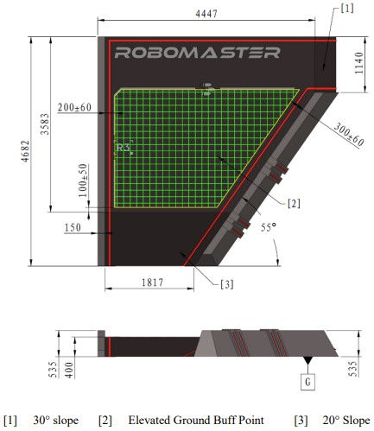
Figure 15: R3 Trapezoid-Shaped Elevated Ground (DJI, 2024)
The green grid area indicates the buff point for both sides. To prepare the Sentry robot for these challenges, a ramp with an upper incline of 30° was simulated, as shown in Figure 16.
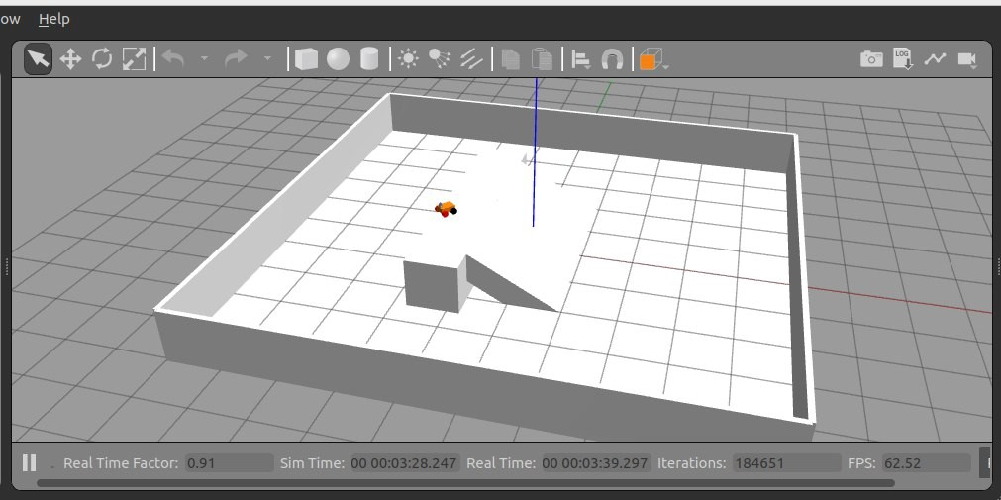
Figure 16: Map created with 30° Inclined Ramp
Each square on the simulation map represents 1 metre, with the top of the ramp reaching approximately 1 metre in height. The extended ramp surface increases the distance the robot must traverse and amplifies the potential for slippage and alignment errors when climbing.
FastLIO was integrated into the simulation for real-time mapping, generating consistent and detailed maps of the environment. Figure 17 illustrates the mapping performance during teleoperation. Localisation was handled using Slam Toolbox, as ICP integration was incomplete.
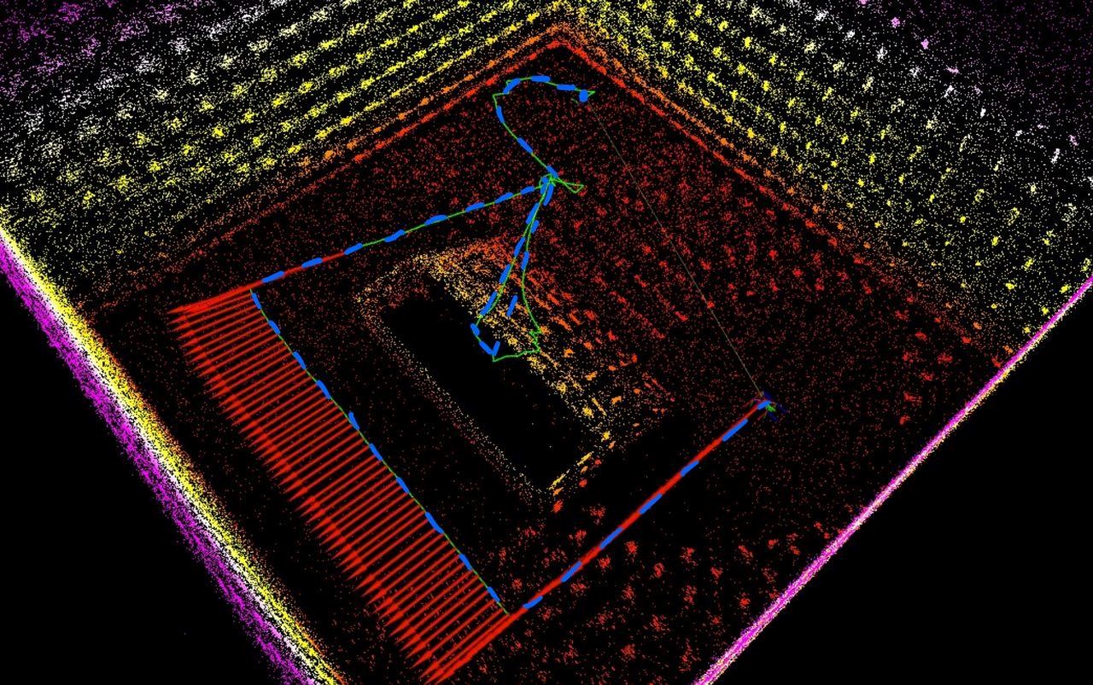
Figure 17: Mapping and movements with FastLIO with teleoperations
In the simulation, the robot employs a mecanum drive controller provided by Gazebo. The blue lines in Figure 9 represent the commanded movement from teleoperations, while the green lines indicate the robot’s actual movement. The red arrow illustrates the robot’s current orientation. On flat surfaces, the robot closely follows the commanded path, with minimal deviation. However, when navigating inclined surfaces, the robot experiences slippage, as evidenced by the discrepancies between the commanded and actual movements while ascending the ramp.
With the navigation parameters provided by Chen (2024), the robot was able to navigate the environment and ascend the ramp, albeit with some drifting and inaccuracies. These issues were primarily attributed to the high-speed spinning of the mecanum drive during operation. A video demonstration of the navigation will be provided in the appendix.

3.2.2 Challenges and Limitations
Simulation testing revealed several challenges and limitations that impacted the system’s overall performance. These issues primarily stemmed from hardware constraints, localisation inaccuracies, and difficulties in navigating inclined surfaces. This section discusses these challenges in detail, highlighting the steps taken to address them and areas requiring further refinement.
One key challenge encountered was related to computational bottlenecks. High-throughput topics, such as LiDAR point clouds, introduced delays in message processing, leading to noticeable performance degradation. These delays were especially evident during mapping and navigation tasks in the simulation, where the system struggled to maintain real-time responsiveness. Figure 18 illustrates an example of delayed messages caused by limited computational resources.
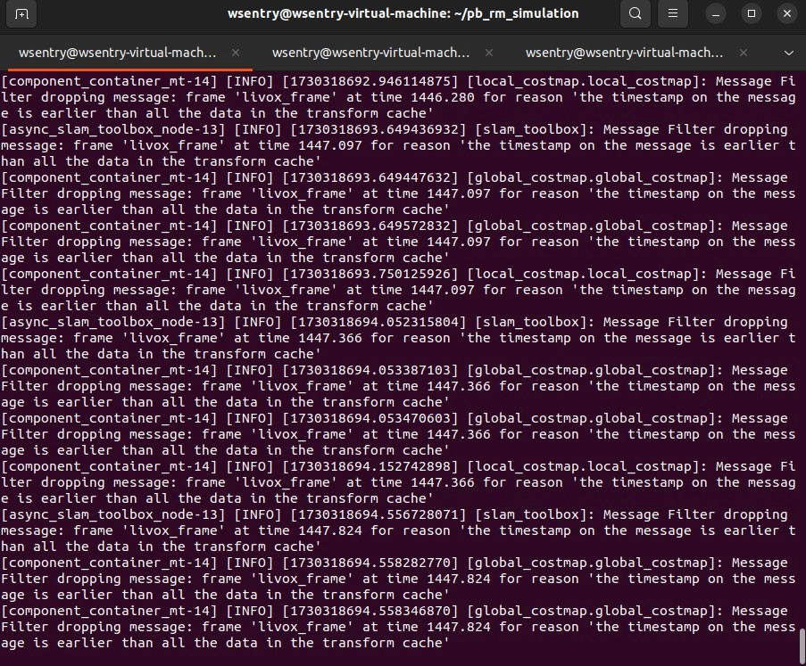
Figure 18: Messages from topics being delayed due to slow message processing
These bottlenecks were partially mitigated by optimising node configurations and reducing topic queue sizes. Running the simulation on a virtual machine further exacerbated these challenges, but the issue was ultimately alleviated by allocating more computational resources to the Ubuntu virtual machine, including 32 GB of RAM, a Ryzen 7500F CPU, and a Radeon 6650xt GPU.
Another limitation was observed in the localisation accuracy during mapping with FastLIO. While the system exhibited reliable mapping capabilities in most scenarios, minor artefacts and frame misalignments occasionally affected localisation accuracy. These issues were particularly noticeable in areas with insufficient unique point features and during rapid spinning or movement. Figure 19 illustrates the localisation results during mapping, highlighting the alignment challenges encountered in the simulation environment.
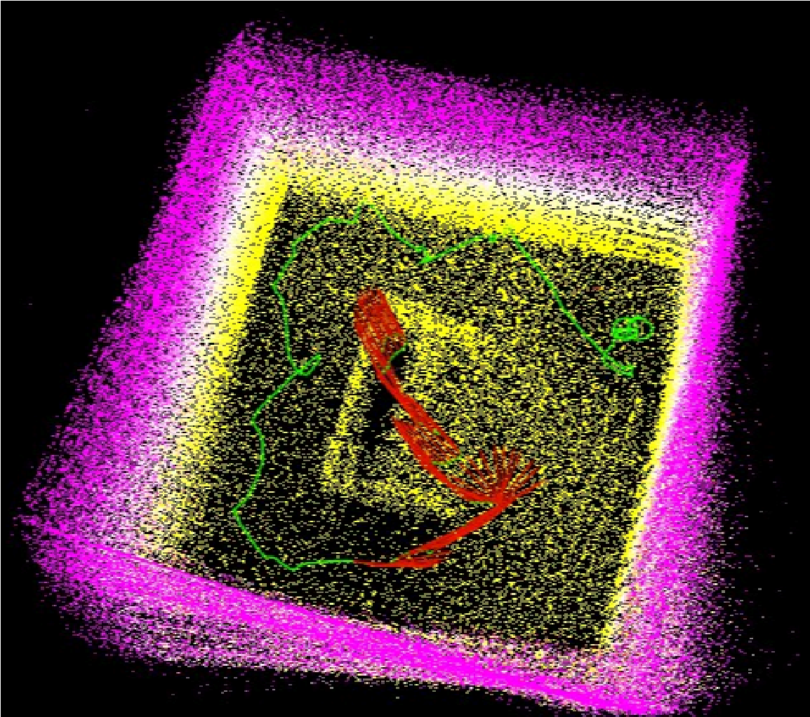
Figure 19: Localisation inaccuracy while mapping with FastLIO
While Slam Toolbox was used for localisation, as ICP integration was incomplete. Minor artefacts and frame misalignments occasionally impacted localisation precision. Despite these limitations, Slam Toolbox successfully validated localisation workflows during testing, achieving alignment in most cases. Further parameter tuning and advanced techniques are necessary to improve overall localisation stability.

4. Conclusion
This project has advanced the autonomous navigation capabilities of the
Robomaster Sentry robot, laying the groundwork for its participation in the RMUC. By transitioning from a visual SLAM approach to a 3D LiDAR-based system, the integration of the Livox Mid360 and FastLIO has significantly enhanced mapping precision and operational efficiency. Despite these advancements, challenges persist, including the unresolved integration of ICP for localisation and the mitigation of IMU drift, which impact overall performance.
Key contributions of this project include the development of a customised power distribution subsystem to accommodate the Livox Mid360’s unique requirements, as well as the creation of a Gazebo simulation framework replicating RMUC conditions. These efforts provided valuable insights into the system’s capabilities, such as its ability to generate accurate 3D maps, while also identifying limitations in navigating complex terrains like ramps.
The findings highlight the need for further development, including optimising localisation algorithms, refining navigation strategies for elevated terrains, and conducting rigorous field testing to bridge the gap between simulated and real-world performance. By addressing these areas, future iterations of the Sentry robot can meet the stringent requirements of RMUC, demonstrating enhanced adaptability and precision in dynamic competition environments. This project underscores the importance of iterative refinement and interdisciplinary collaboration in developing high-performance autonomous systems for competitive robotics.

5. Future Work
Building upon the advancements achieved in this project, several critical areas require further development to enhance the Sentry robot’s performance. This section outlines two main focus areas: improving localization accuracy through ICP integration and refining navigation strategies for ramp traversal.

5.1 Integration of ICP for Localisation
The integration of ICP remains a critical area for future improvement, as it would enhance the alignment of live LiDAR scans with pre-mapped environments. While FastLIO provides efficient real-time mapping, incorporating ICP would improve localisation accuracy. Besl and McKay (1992) demonstrated ICP's precision for pose refinement, and newer approaches like Generalized-ICP (Segal et al., 2009) have shown robustness under noisy conditions. Optimised implementations such as LOAM (Zhang & Singh, 2014) could further reduce computational overhead, making real-time ICP feasible for the Sentry robot.

5.2 Improved Navigation on Ramps
The robot’s current navigation stack struggles with ramp traversal due to the misclassification of slopes as obstacles. Future efforts should focus on refining terrain costmaps and navigation parameters to improve ramp handling. Research by Wang et al. (2017) demonstrated that incorporating terrain-specific costmaps significantly enhances mobility over uneven surfaces. Additionally, graph-based waypoint navigation, as explored by Rogers et al. (2023), could offer smoother traversal by providing intermediate navigation points to guide the robot effectively over ramps and other challenging terrains.

Citation and References
Besl, P. J., & McKay, N. D. (1992). A method for registration of 3-D shapes. IEEE Transactions on Pattern Analysis and Machine Intelligence, 14(2), 239–256. https://doi.org/10.1109/34.121791
Cadena, C., Carlone, L., Carrillo, H., Latif, Y., Scaramuzza, D., Neira, J., Reid, I., & Leonard, J. J. (2016). Past, present, and future of simultaneous localization and mapping: Towards the robust-perception age. IEEE Transactions on Robotics, 32(6),
1309–1332. https://doi.org/10.1109/TRO.2016.2624754
Chen, L. (2024). pb_rm_simulation [Computer software]. GitHub. https://github.com/LihanChen2004/pb_rm_simulation
DJI. (2024). Robomaster University Championship (RMUC) 2024 regulations.
Robomaster. https://www.robomaster.com/en-US/resource/pages/announcement/1658
HKU-MARS Lab. (2021). FAST_LIO: A fast, robust LiDAR-inertial odometry package
[Computer software]. GitHub. https://github.com/hku-mars/FAST_LIO
Labbé, M., & Michaud, F. (2019). RTAB-Map as an open-source lidar and visual
SLAM library for large-scale and long-term online operation. Journal of Field
Robotics, 36(2), 416–446. https://doi.org/10.1002/rob.21831
Livox. (n.d.). Livox Mid360 specifications. Retrieved November 2024, from https://www.livoxtech.com/
Macenski, S., & Jambrecic, I. (2021). Slam toolbox: SLAM for the dynamic world.
Journal of Open Source Software, 6(61), 2783. https://doi.org/10.21105/joss.02783
NVIDIA. (n.d.). Jetson Orin: The world’s most powerful AI computer for energy-efficient autonomous machines. NVIDIA. https://www.nvidia.com/en-sg/autonomous-machines/embedded-systems/jetson-orin/
Open Robotics. (2024). ROS 2 (Robot Operating System) [Computer software]. https://docs.ros.org/en/humble/index.html/
Rogers, H., Sellers, T., Lei, T., Carruth, D., & Luo, C. (2023). Sensor-Based Multi-Waypoint Autonomous Robot Navigation with Graph-Based Models.
Proceedings of SPIE, 6, https://doi.org/10.1117/12.2663830
Segal, A., Haehnel, D., & Thrun, S. (2009). Generalized-ICP. Proceedings of
Robotics: Science and Systems (RSS). https://doi.org/10.15607/RSS.2009.V.021
Wang, C., Meng, L., She, S., Mitchell, I., Li, T., Tung, F., Wan, W., Meng, M., & Clarence, D. S. (2017). Autonomous mobile robot navigation in uneven and unstructured indoor environments. Proceedings of the IEEE/RSJ International Conference on Intelligent Robots and Systems (IROS), 109–116. https://doi.org/10.1109/IROS.2017.8202145
Xu, W., & Zhang, F. (2021). FAST-LIO: A Fast, Robust LiDAR-inertial Odometry
Package by Tightly-Coupled Iterated Kalman Filter. IEEE Robotics and Automation
Letters, 6(2), 1400–1407. https://doi.org/10.1109/LRA.2021.3064227
Yue, X., & He, M. (2023). LiDAR-based SLAM for robotic mapping: State of the art and new frontiers. arXiv preprint. https://arxiv.org/pdf/2311.00276
Zhang, J., & Singh, S. (2020). LOAM: Lidar Odometry and Mapping in Real-time.
Robotics: Science and Systems Conference (RSS), 2020.
https://doi.org/10.15607/RSS.2014.X.007

Appendix

A. Video Demonstration
Unlisted YouTube Link: Simulated Robot Navigating Ramp

B. GitHub Repository
Forked Simulation Framework: pb_rm_simulation on GitHub

C. Setup Instructions
- Install SSD and Flash Jetpack
  - Install the SSD on your Jetson Orin.
  - Flash Jetpack 6.0 or the latest version using NVIDIA SDK Manager:
    - Download: NVIDIA SDK Manager
○ Ensure you are using amd64 Ubuntu.
○ Disable screen timeout to prevent interruptions during installation.

- Configure Power and CPU
  - Adjust the power and CPU configuration as needed:
    - Reference: Compute Setup for NVIDIA
  - Skip the Docker setup unless explicitly required.

- Install ROS and Isaac ROS
  - Install ROS2 and Isaac ROS following these instructions:
    - Isaac APT Repository Installation Guide

- Livox Mid360 Setup
  - Connect Hardware:
    - Plug in the power supply to the Livox Mid360 using 24V and 1A max.
○ Connect the LiDAR via Ethernet to the Jetson Orin.
○ Ignore splitter cables and GPS configuration.
  - Reference Guides:
    - Livox Mid360 User Manual
○ Livox Mid360 Quick Start Guide
  - Set LiDAR and PC IP Configuration:
    - The Livox Mid360 LiDAR’s IP is set to 192.168.1.1XX, where XX is the last two digits of the serial number (e.g., 192.168.1.181).
○ Set the PC's static IP address based on the manual (Pages 10–11):
■ Windows:
■ Open Control Panel > Network and Sharing Center.
■ Select your network, click Properties, and choose Internet Protocol Version 4 (TCP/IPv4).
■ Set the static IP address to 192.168.1.50 and the subnet mask to 255.255.255.0.
■ Click OK to save.
■ Ubuntu 18.04:
sudo ifconfig eth0 192.168.1.50 netmask
255.255.255.0
Replace eth0 with your network port name if necessary.
■ For persistent static IP configuration, manually edit Settings in the Network menu.
Note: Ethernet may disconnect randomly; ensure settings persist across restarts.

5. FAST_LIO and Livox Configuration
- Clone and Install Dependencies:
  - Follow the FAST_LIO ROS2 README.
○ Install dependencies:
■ PCL (Point Cloud Library)
■ Eigen (Linear Algebra Library) ■ Livox ROS Driver (Livox SDK2)
- Important Notes:
  - Do not run rm -rf commands; they may remove essential SDKs.
○ Follow the forked version: Livox ROS Driver2.
- Run Livox ROS Driver:
cd <ros_ws> source ./install/setup.sh
ros2 launch livox_ros_driver2 [launch file]
○ Choose the appropriate launch file:
■ msg_MID360_launch.py for creating publishers.
■ rviz_MID360_launch.py for visualising point clouds in RViz.
4. Update Configurations:
○ Modify the config/MID360_config.json file to match the LiDAR IP settings and desired publishing frequencies.

6. Run FAST_LIO
- Install FAST_LIO:
  - Follow the installation steps for FAST_LIO and ensure compatibility with ROS2.
- Launch FAST_LIO for Mapping:
cd <ros2_ws> source ./install/setup.sh
ros2 launch fast_lio mapping.launch.py config_file:=mid360.yaml

Additional Notes
- The publishing frequency and other configurations for Livox and FAST_LIO can be modified in the respective configuration files from Eric's GitHub.
- For LiDAR setup issues, refer to:
  - Livox SDK2
- For ROS2 or FAST_LIO errors, consult their documentation or GitHub repositories.
Good luck with your setup!

D. Python Code for Saving PCD Files
import rclpy from rclpy.node import Node from sensor_msgs.msg import PointCloud2 import open3d as o3d

import numpy as np import struct
class MapSaver(Node):
def __init__(self):
super().__init__('map_saver') qos_profile = rclpy.qos.qos_profile_sensor_data
# Subscribe to the cumulative map topic (replace with actual topic) self.create_subscription(PointCloud2, "/Laser_map",
self.map_callback, qos_profile) self.get_logger().info('MapSaver Node has been started.')
def map_callback(self, msg):
self.get_logger().info('Received map data.') map_cloud = self.pointcloud2_to_open3d(msg) o3d.io.write_point_cloud("fastlio_map.pcd", map_cloud) self.get_logger().info("Saved map data to
fastlio_map.pcd")
def pointcloud2_to_open3d(self, cloud_msg): points = [] for i in range(0, len(cloud_msg.data),
cloud_msg.point_step): x, y, z = struct.unpack_from('fff', cloud_msg.data,
offset=i) points.append([x, y, z])
map_cloud = o3d.geometry.PointCloud() map_cloud.points =
o3d.utility.Vector3dVector(np.array(points)) return map_cloud
def main(args=None):
rclpy.init(args=args) map_saver = MapSaver() rclpy.spin(map_saver) map_saver.destroy_node() rclpy.shutdown()
if __name__ == '__main__':
main()

E. Overall Modified Hardware Diagram for Livox Mid360
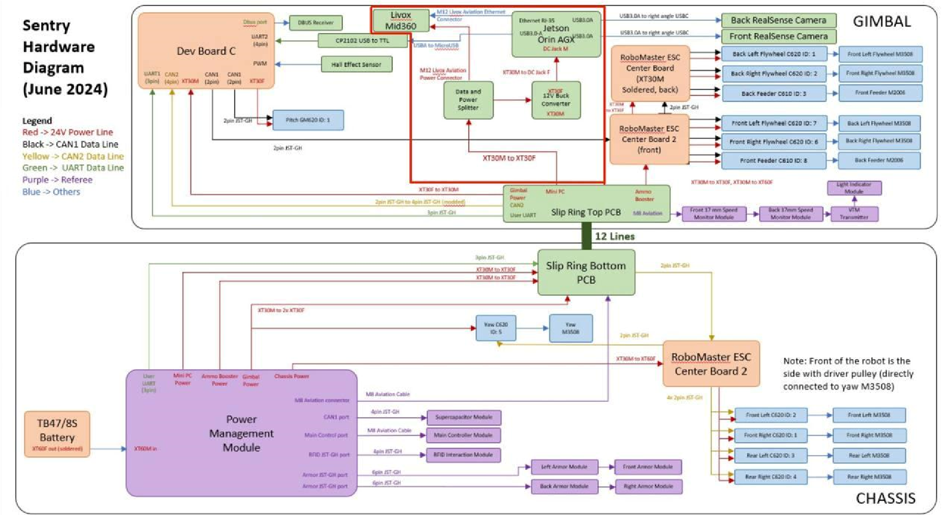
Figure 20: Overall Modified Hardware Diagram for Livox Mid360

3.1 Load Tests (Load regulation under step loads) and extended runtimes 17
5.1 Optimizing Layout to reduce noise 25
5.2 Development of housekeeping add-on board allowing digital program 25

